Conditional Independence: Free × Ads × Age Rating → Installs
We examine whether monetization (Y) and installs (Z) remain related once we control for age rating (X).

Variables
• Y = Monetization Type → i = 0 (Free + No Ads), i = 1 (Free + Ads)
• Z = Install Level → j = 0 (Low installs <100M), j = 1 (High installs ≥100M)
• X = Age Rating → k = 0 (<18), k = 1 (18+)
• Total sample size: N = 12,000
• Symbol ⫫̸ shows dependence (no independence)
• Symbol ⫫ shows independence

1. Marginal Table (Y × Z)
 | Z = 0 (j=0) (Low installs) | Z = 1 (j=1)  (High installs) | Row total
Y = 0 (i=0) (free + No Ads) | n00 = 2040 | n01 = 2460 | n0+ = 4500
Y = 1 (i=1) (free + Ads) | n10 = 3660 | n11 = 3840 | n1+ = 7500
Column total | n+0 = 5700 | n+1 = 6300 | n++ = 12000
Conditional independence check:
P(Y=1 | Z=0) = n10 / n+0 = 3660 / 5700 = 0.642
P(Y=1 | Z=1) = n11 / n+1 = 3840 / 6300 = 0.609
P(Y=1 | Z=0) ≠ P(Y=1 | Z=1)
Thus, Y and Z appear dependent. Y ⫫̸ Z (Y is NOT independent of Z)

2. Conditional Tables with X (Age)
We split the data by age to check whether the Y–Z relationship persists within each age group, computing nᵢⱼ|ₖ for each level of X to examine conditional independence.

2.1 Age < 18 (X = 0 → k = 0)
Counts within this age group (nᵢⱼ|₀). Total: n₊₊|₀ = 3500.
 | Z = 0 (j=0) | Z = 1 (j=1) | Row total
Y = 0 (i=0) | n00|0 = 1200 | n01|0 = 1600 | n0+|0 = 2800
Y = 1 (i=1) | n10|0 = 300 | n11|0 = 400 | n1+|0 = 700
Column total | n+0|0 = 1500 | n+1|0 = 2000 | n++|0 = 3500
Conditional independence check:
P(Y=1 | Z=0, X=0) = n10|0 / n+0|0 = 300 / 1500 = 0.20
P(Y=1 | Z=1, X=0) = n11|0 / n+1|0 = 400 / 2000 = 0.20
Since these probabilities are equal, Y ⫫ Z | X = 0.
Meaning: for under-18 apps, monetization does not affect installs.

2.2 Age ≥ 18 (X = 1 → k = 1)
Counts within this age group (nᵢⱼ|₁). Total: n₊₊|₁ = 8500.
 | Z = 0 (j=0) | Z = 1 (j=1) | Row total
Y = 0 (i=0) | n00|1 = 840 | n01|1 = 860 | n0+|1 = 1700
Y = 1 (i=1) | n10|1 = 3360 | n11|1 = 3440 | n1+|1 = 6800
Column total | n+0|1 = 4200 | n+1|1 = 4300 | n++|1 = 8500
Conditional independence check:
P(Y=1 | Z=0, X=1) = n10|1 / n+0|1 = 3360 / 4200 = 0.80
P(Y=1 | Z=1, X=1) = n11|1 / n+1|1 = 3440 / 4300 = 0.80
Since these probabilities are equal, Y ⫫ Z | X = 1.
Meaning: for 18+ apps, monetization and installs are unrelated once we control for age.

Interpretation
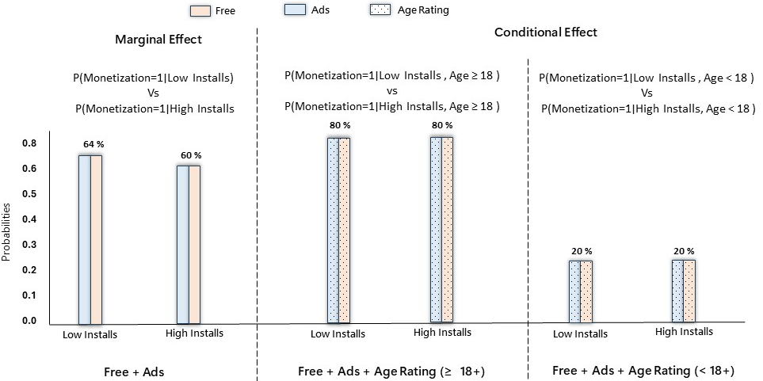
In the overall dataset, free games with ads appear slightly more likely to have higher install levels. However, when the data are separated by age rating, this pattern disappears completely. Within both age groups (<18 and 18+), the share of ad-supported free games is the same for low-install and high-install games. This means that the small relationship seen in the aggregate is not due to monetization itself but rather to differences in how games are distributed across age categories. Once age rating is taken into account, install levels do not vary by monetization type, indicating that age rating, not monetization, explains the observed differences in installs.

